**Sorting Algorithms**

**Bubble:**

Bubble Sort is the simplest sorting algorithm that works by repeatedly swapping the adjacent elements if they are in the wrong order.

This is a very slow sorting algorithm compared to algorithms like quicksort, with worst-case complexity. However, the tradeoff is that bubble sort is one of the easiest sorting algorithms to implement from scratch.

<https://www.geeksforgeeks.org/bubble-sort/>

<https://www.youtube.com/watch?v=nmhjrI-aW5o>

**Merge:**

The Merge Sort Algorithm, merge sort is one of the most efficient sorting algorithms. It works on the principle of Divide and Conquer. Merge sort repeatedly breaks down a list into several sublists until each sublist consists of a single element and merging those sublists in a manner that results in-to a sorted list.

<https://www.geeksforgeeks.org/merge-sort/>

<https://www.youtube.com/watch?v=JSceec-wEyw>

<https://youtu.be/4VqmGXwpLqc>

**Quicksort:**

Quicksort (sometimes called partition-exchange sort) is an efficient sorting algorithm, serving as a systematic method for placing the elements of a random access file or an array in order. ... Mathematical analysis of quicksort shows that, on average, the algorithm takes O(n log n) comparisons to sort n items.

<https://www.geeksforgeeks.org/quick-sort/>

https://www.youtube.com/watch?v=PgBzjlCcFvc

**⅔ together (Bubble + Merge Explained:**

[**https://youtu.be/qfs9Kt5Rkj0**](https://youtu.be/qfs9Kt5Rkj0)

**Other Interesting Pieces:**

<https://www.youtube.com/watch?v=hOkPg3rXt34>

<https://www.youtube.com/watch?v=Y0-9xN36MrM>

<https://www.youtube.com/watch?v=kPRA0W1kECg>

<https://www.youtube.com/watch?v=ZZuD6iUe3Pc>

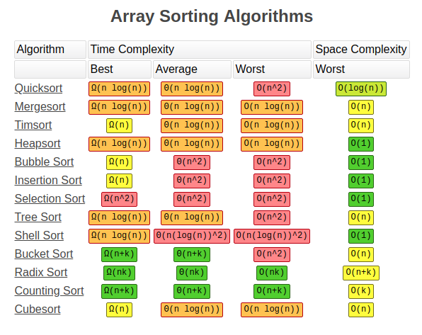

Effectiveness/Speed Of Different Algorithms:

